Portfolio Milestone Part II

Jeff Crowder
Colorado State University Global
CSC450-1: Programming III
Professor Russell Frith
Due Date: 11/08/2026

Portfolio Milestone Part II

Part 1 - Pseudocode:

Start Program

Display a message indicating the counter application is starting

Create a function named countUp

Display a heading indicating Thread 1 is counting up

Loop from 0 through 20

Display the current number

Pause briefly before displaying the next number

Create a function named countDown

Display a heading indicating Thread 2 is counting down

Loop from 20 down to 0

Display the current number

Pause briefly before displaying the next number

Create Thread 1 using the countUp function

Start Thread 1

Wait for Thread 1 to complete execution

Create Thread 2 using the countDown function

Start Thread 2

Wait for Thread 2 to complete execution

Display a message indicating the program has completed successfully

End Program
Part 2 - Source Code:

package p3pp2;

public class ThreadCounterApp {

// the thread function to count from 0 to 20
public static void countUp() {

System.out.println("Thread 1 Start: Begin Counting Up to 20");

for (int i = 0; i <= 20; i++) {
System.out.println(i);

try {
// pauses for 250 milliseconds between counts for better count visibility
Thread.sleep(250);
} catch (InterruptedException e) {
e.printStackTrace();
}
}
}

// the thread function to count from 20 to 0
public static void countDown() {

System.out.println("Thread 2 Start: Begin Counting Down to 0");

for (int i = 20; i >= 0; i--) {
System.out.println(i);

try {
// pauses for 250 milliseconds between counts for better count visibility
Thread.sleep(250);
} catch (InterruptedException e) {
e.printStackTrace();
}
}
}

public static void main(String[] args) {

System.out.println("Launching Counter Application!");

// create the first thread
Thread thread1 = new Thread(() -> countUp());

try {

// waits for thread 1 to finish
thread1.start();
thread1.join();

// creates a second thread
Thread thread2 = new Thread(() -> countDown());

// waits for thread 2 to finish
thread2.start();
thread2.join();

} catch (InterruptedException e) {
e.printStackTrace();
}

System.out.println("Program Complete!");
}
}
Part 3 - Screenshots:

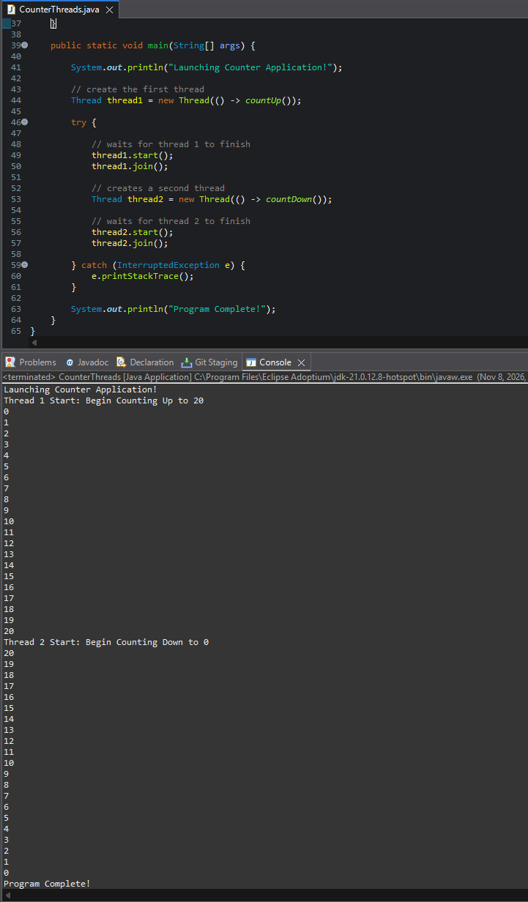
Part 4 – Program Analysis:

Concurrency and Performance
Concurrency can improve the responsiveness and efficiency of an application or program by letting tasks run through separate threads. In my Java application, two threads run counting operations. The first thread counts from 0 to 20, and once that thread completes, the second thread starts and begins to count from 20 back down to 0. This design shows thread creation, execution, and synchronization.
Though the application only uses two threads, there would still performance overhead because of multithreading. The Java Virtual Machine needs to assign memory and system resources for each thread and coordinate their execution. Another potential performance concern is context switching, which occurs when the processor shifts from one thread to another. Constantly switching back and forth can reduce efficiency since the processor is being used more frequently to manage threads, rather than performing useful work. In this application, that impact is minimal because only two threads are created and they execute sequentially through the use of the join() method. As a result, the program shows concurrency concepts while also keeping performance overhead low.

Vulnerability with Strings
String handling could bring in security concerns in software applications, especially when input is not correctly validated. One of the advantages of using Java is that it uses the built-in String class rather than C-style character arrays. This helps reduce the risk of common memory-related vulnerabilities since memory management would be handled automatically by the JVM.
The application that I created for this portfolio project has limited string related risks, because it does not accept user input and only shows predefined messages to the console. Because the strings are controlled completely within the program, there is little opportunity for string manipulation attacks. If the application were expanded to accept user input in the future, proper validation and sanitization techniques should be implemented to make sure that unexpected or malicious data can’t affect program behavior.

Data Type Security
The main data type that is used in this application is the integer (int) data type. The counter variables will only store values between 0 and 20, which is well within the range of valid integer values. Since this range is so limited, there is no real risk of integer overflow when the program runs. Another security risk worth looking into with multithreaded applications, would be maintaining data integrity when multiple threads are active. Issues like race conditions can happen when threads try to access or modify the same data at the same time. In this application, we avoid that risk since the threads do not share data, and run one after the other. The join() method makes sure that the first thread completes before the second thread begins. This approach provides proper synchronization and helps maintain consistent program behavior. By limiting variable usage and avoiding shared resources, the application demonstrates secure handling of data types within a concurrent environment.

Git Repository Link
https://github.com/jeffreycrowder-ops


